

(23CSE111) object-OrenteD Programing LAB MANUAL

CSE-1st YEAR I SEMESTER (2024-2025)

SUBMITTED From: SUBMITTED To:

|  |  |  |  |
| --- | --- | --- | --- |
| **NAME** | G. Chaitanya Raja  Reddy | **NAME** | **Dr.Raj Kumar Batchu** |
| **ROLL NO** | **AV.SC.U4CSE24112** | **DEPARTMAENT** | **Ogject-Orented_programing** |
| **SECTION** | **CSE-B** | **DESIGNATION** | **PROFESSOR** |

|  |  |
| --- | --- |
| **MARKS** |  |
| **DATE** |  |
| **SIGNATURE** |  |

INDEX

|  |  |  |  |
| --- | --- | --- | --- |
| **S.NO** | **TITLE** | **PAGES** | **SIGN** |
| week1. | Installing jdk  And running the basic information about a student | 1-5 |  |
| week2. | 1.Factorial series.  2.Simple Intreset.  3.Fibonacci Series.  4.Area of Triangle using herons, Formula and Area of Rectangle.  5.convertion from celcius to farenheit. | 5-11 |  |
| week3. | 1.About Car Class.  2.About BankAccounts class | 11-18 |  |
| week4. |  |  |  |
| week5. |  |  |  |
| week6. | . |  |  |
| week7. |  |  |  |
| week8. |  |  |  |
| week9. | . |  |  |
| week10. |  |  |  |

**How to download and install java software in your computer.**

**1.Steps for downloading.**

Step 1: java is downloaded from the official Oracle website,open web browser and search jdk download

Step 2: Then go to the website https://www.oracle.com/in/java/technologies/downloads/

Step 3: And navigate to the java downloads. Then some earlier versions are available like

* [JDK 23](https://www.oracle.com/in/java/technologies/downloads/#java23)
* [JDK 21](https://www.oracle.com/in/java/technologies/downloads/#java21)
* [GraalVM for JDK 23](https://www.oracle.com/in/java/technologies/downloads/#graalvmjava23)
* [GraalVM for JDK 21](https://www.oracle.com/in/java/technologies/downloads/#graalvmjava21)

Step 4:Now click on JDK 21 .this is the latest Long-Term Support (LTS) release of the Java SE Platform

Step 5: then select the type of operating system of your device

Step 6:now press the second link as shown in the image

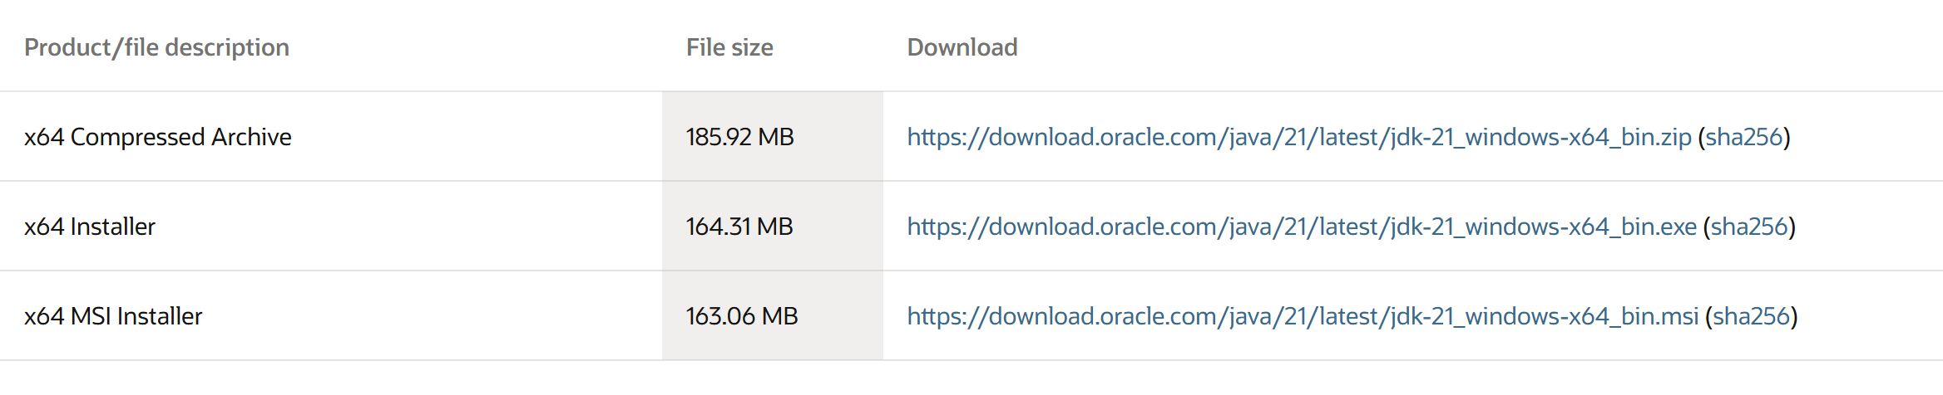

Click on x64 installer link

**2.Steps for installation.**

Step 1 : after downloading that link go to the folder where it was downloaded

Step 2: then open it and accept all terms and conditions

Step 3: then instal it

**3.Setting environmental variables.**

Step 1: Open file explorer, then right click on This PC next select on properties then it will take you to the settings app then click on advanced system settings and then click on Environment Variables.

Step 2: Click New under System Variables:

Set variable name as:java_

Variable value: The folder address where JDK is installed (like C:\Program Files\Java\jdk-21\bin)

Step 3: Find Path under System Variables, click Edit, and add the path of the jdk-21(C:\Program Files\Java\jdk-21\bin)

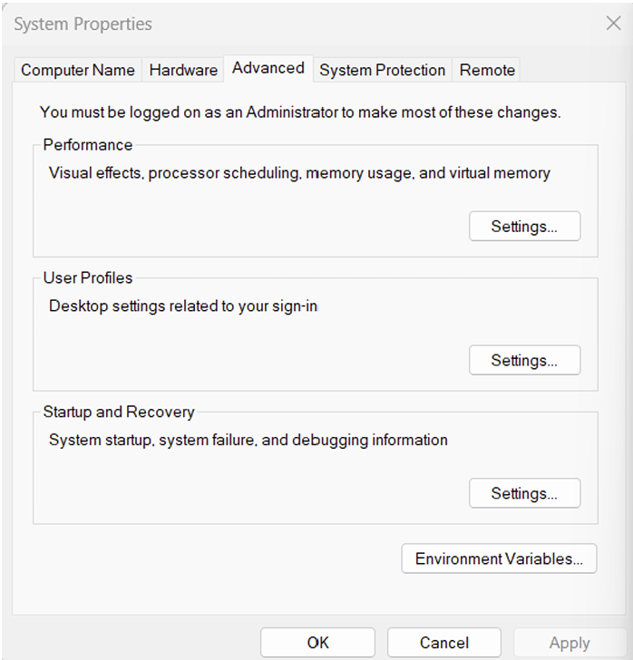

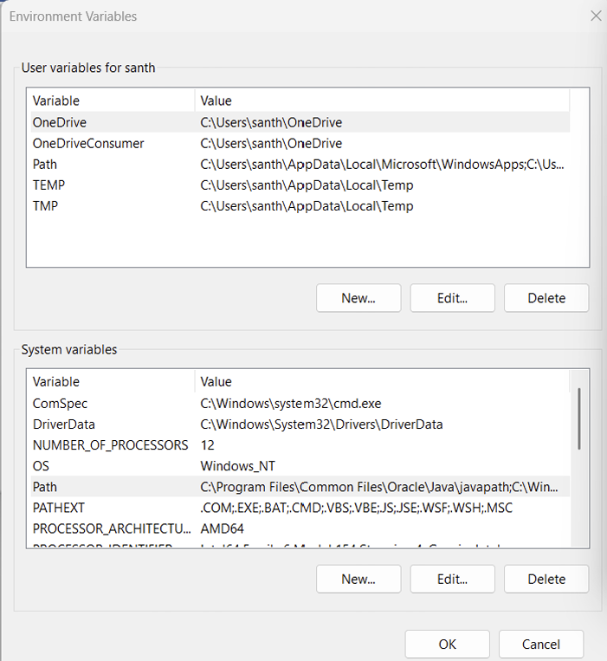

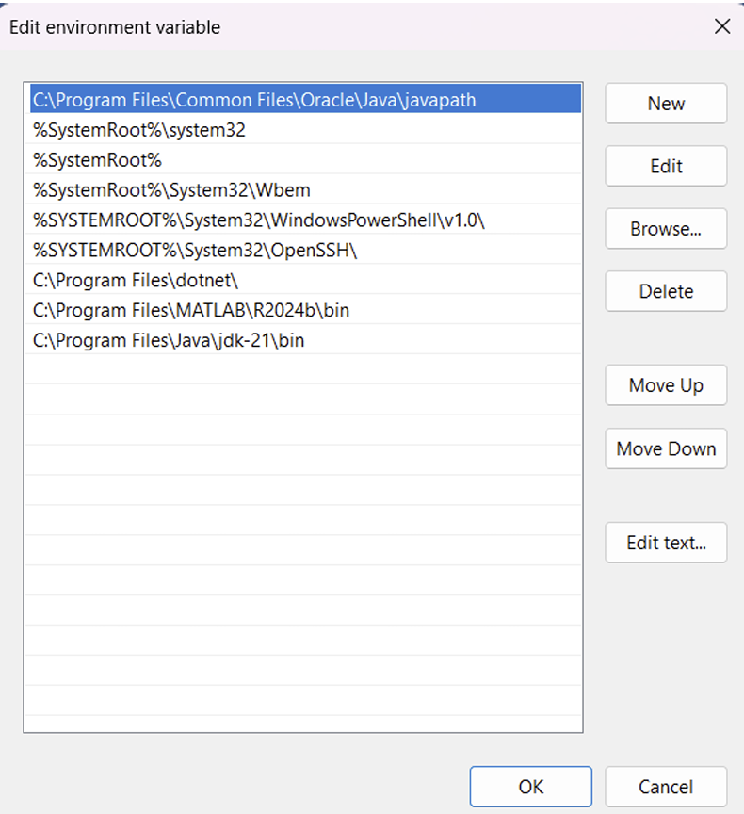

**4.Checking for jdk(java development kit) version.**

Step 1: Open command promt.

Step 2: Enter javac --version in the command promt for version of jdk installed

Step 3: Enter java –version for all details like when downloaded and path of environment variables.

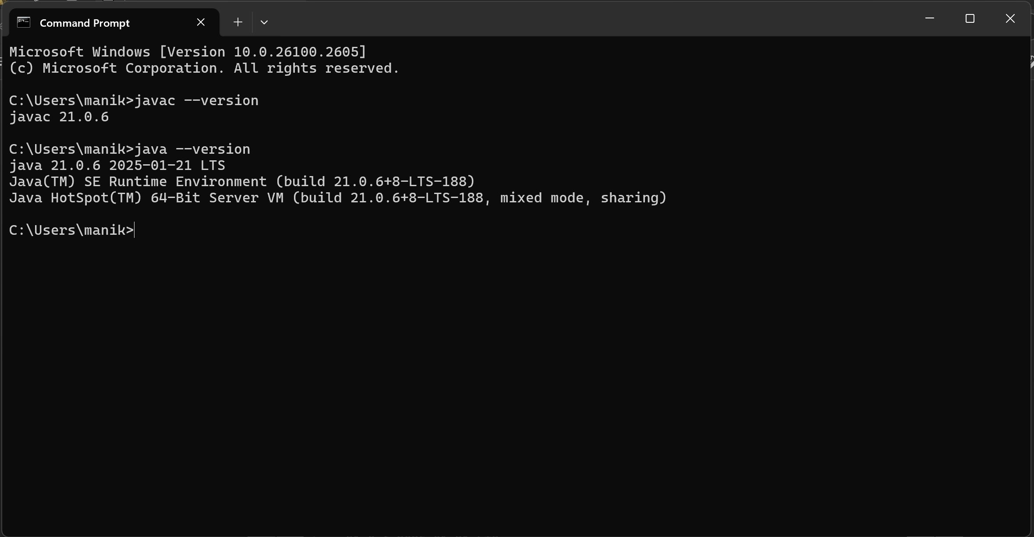

**WRITE A SIMPLE JAVA CODE FOR YOUR NAME,SECTION,ROLL NO AND BRANCH**

**class Me**

**{**

**public static void main(String[] args)**

**{**

**System.out.println("NAME=G.Chaitanya Raja Reddy");**

**System.out.println("SECTION=b");**

**System.out.println("ROLL NO=av.sc.u4cse24145");**

**System.out.println("BRANCH=cse");**

**System.out.println(“college=Amrita Vishwa Vidyapeeth”)**

**}**

**}**

**Output:**

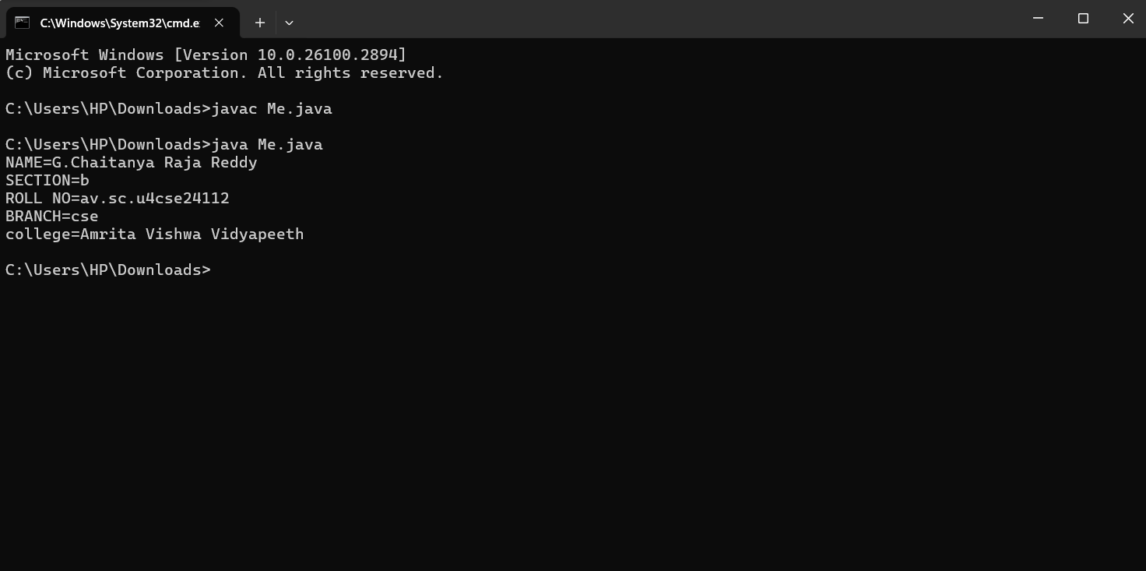

**Week-2**

**1.Factrioal series**

**Code:**

**import java.util.Scanner;**

**class FactorialSeries {**

**public static void main(String[] args) {**

**Scanner input = new Scanner(System.in);**

**System.out.print("Enter the number: ");**

**int n = input.nextInt();**

**int fact = 1;**

**for (int i = 1; i <= n; i++) {**

**fact *= i;**

**System.out.println(i + "! = " + fact);**

**}**

**input.close();**

**}**

**}**

**Output:**

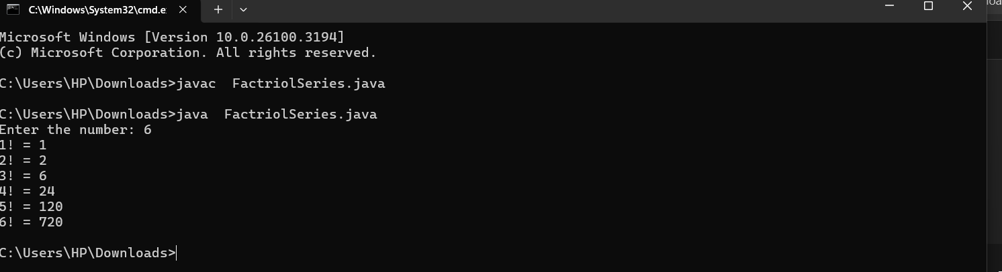

**Errors:**

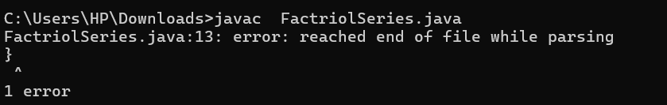

**2.Simple Interest**

**Code:**

**import java.util.Scanner;**

**class SimpleInterest {**

**public static void main(String[] args) {**

**Scanner input = new Scanner(System.in);**

**// Simple Interest Calculation**

**System.out.print("Enter Principal amount: ");**

**double principal = input.nextDouble();**

**System.out.print("Enter Rate of interest: ");**

**double rate = input.nextDouble();**

**System.out.print("Enter Time (in years): ");**

**double time = input.nextDouble();**

**double simpleInterest = (principal * rate * time) / 100;**

**System.out.println("Simple Interest: " + simpleInterest);**

**input.close();**

**}**

**}**

**Output:**

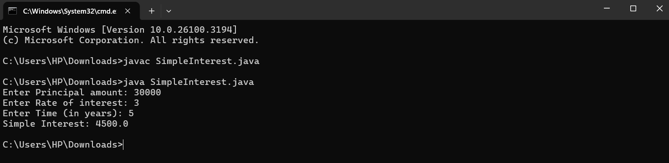

(No errors occurred in this code )

**3.Fibnocci Series:**

**Code:**

**import java.util.Scanner;**

**class FibonacciSeries {**

**public static void main(String[] args) {**

**Scanner input = new Scanner(System.in);**

**System.out.print("Enter number of terms for Fibonacci series: ");**

**int n = input.nextInt();**

**int a = 0, b = 1;**

**System.out.print("Fibonacci Series: " + a + " " + b);**

**for (int i = 3; i <= n; i++) {**

**int next = a + b;**

**System.out.print(" " + next);**

**a = b;**

**b = next;**

**}**

**input.close();**

**}**

**}**

**Output:**

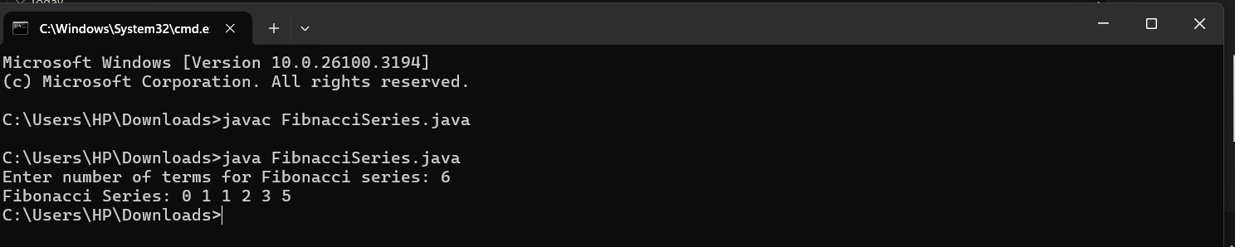

**Errors table and rectification**

|  |  |
| --- | --- |
| **1.Giving space between next and Double.**  **2.Not giving parenthesis after closing the input.** | **1.Should not give space between next and Double.**  **2.We must put parenthesis after closing the input.** |

**4.Area of Triangle:**

**Code:**

**import java.util.Scanner;**

**public class HeronsFormula {**

**public static void main(String[] args) {**

**Scanner sc = new Scanner(System.in);**

**System.out.print("Enter side a: ");**

**double a = sc.nextDouble();**

**System.out.print("Enter side b: ");**

**double b = sc.nextDouble();**

**System.out.print("Enter side c: ");**

**double c = sc.nextDouble();**

**double s = (a + b + c) / 2; // Semi-perimeter**

**double area = Math.sqrt(s * (s - a) * (s - b) * (s - c));**

**System.out.println("Area of Triangle using Heron's formula: " + area);**

**sc.close();**

**}**

**}**

**Output:**

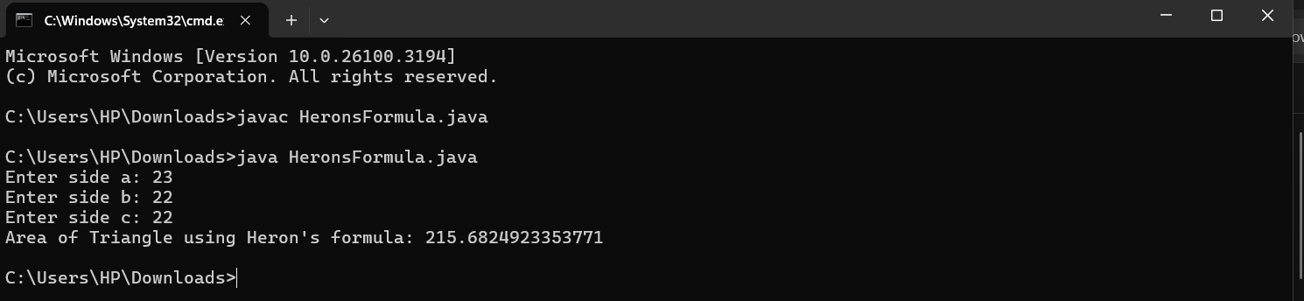

(No errors occurred in this code )

**Area of Rectangle:**

**Code:**

**import java.util.Scanner;**

**public class RectangleArea {**

**public static void main(String[] args) {**

**Scanner sc = new Scanner(System.in);**

**System.out.print("Enter length of the rectangle: ");**

**double length = sc.nextDouble();**

**System.out.print("Enter breadth of the rectangle: ");**

**double breadth = sc.nextDouble();**

**double area = length * breadth;**

**System.out.println("Area of Rectangle: " + area);**

**sc.close();**

**}**

**}**

**Output:**

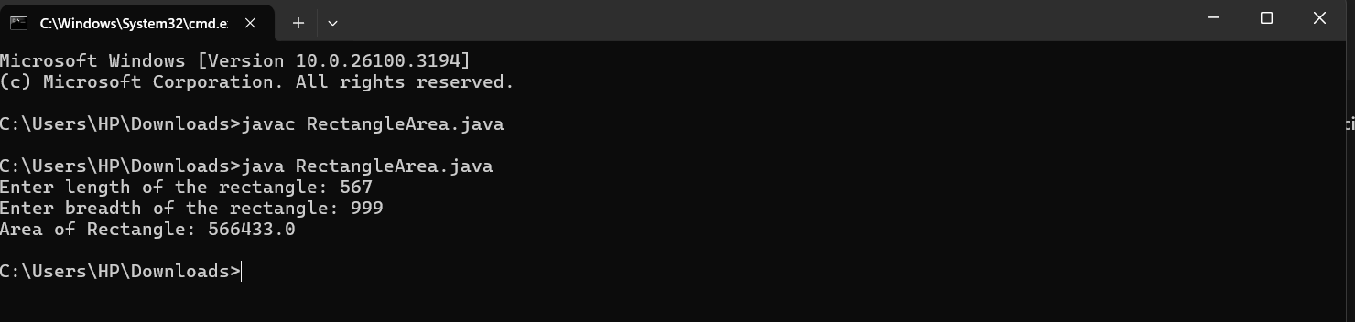

(No errors occurred in this code )

**5.Convert of temperature:**

**Code:**

**import java.util.Scanner;**

**class TemperatureConverter {**

**public static void main(String[] args) {**

**Scanner input = new Scanner(System.in);**

**// Prompt user to enter temperature in Celsius**

**System.out.print("Enter temperature in Celsius: ");**

**double celsius = input.nextDouble();**

**// Convert Celsius to Fahrenheit**

**double fahrenheit = (celsius * 9 / 5) + 32;**

**// Display the result**

**System.out.printf("%.2f Celsius is equal to %.2f Fahrenheit%n", celsius, fahrenheit);**

**input.close();**

**}**

**}**

**Output:**

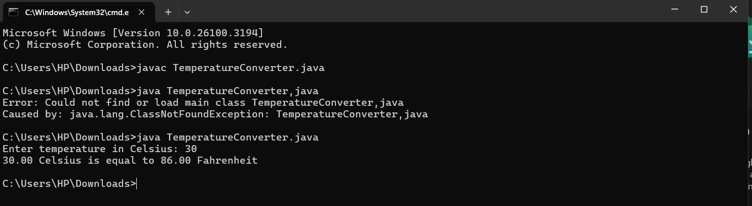

(No errors occurred in this code )

**Week-3**

Write a Java program with the following instructions:

1. Create a class with name Car

2. Create four attributes

car colour

car brand

mileage

injector type

3. Create three methods

start

stop

service

4. Create three objects C1, C2, C3

5. Create a constructor with parameters

.car color

.car brand

.milage

.fuel type

Code:

class Car{

String car_color;

String car_brand;

String fuel_type;

String milage;

public void start(){

System.out.println("the car started with a roaring dragon sound....");

}

public void stop(){

System.out.println("the car as stopped with a great skid....");

}

public void service(){

System.out.println("the went to garage with a huge accident at our road side pole.....");

}

public static void main(String[] args){

Car C1 = new Car();

C1.car_color = "navy blue";

C1.car_brand = "roles roys";

C1.fuel_type = "CNG gas,Deseil";

C1.milage = "15km/hr";

System.out.println("the car color is" + C1.car_color);

System.out.println( "the brand of car is" + C1.car_brand);

System.out.println("the fuel type is" + C1.fuel_type);

System.out.println("the milage give by the car is" + C1.milage);

Car C2 = new Car();

C2.car_color = " blue";

C2.car_brand = "BMW";

C2.fuel_type = "Deseil";

C2.milage = "17km/hr";

System.out.println("the car color is" + C2.car_color);

System.out.println( "the brand of car is" + C2.car_brand);

System.out.println("the fuel type is" + C2.fuel_type);

System.out.println("the milage give by the car is" + C2.milage);

Car C3 = new Car();

C3.car_color = " red";

C3.car_brand = "Audi";

C3.fuel_type = "Deseil";

C3.milage = "20km/hr";

System.out.println("the car color is" + C3.car_color);

System.out.println( "the brand of car is" + C3.car_brand);

System.out.println("the fuel type is" + C3.fuel_type);

System.out.println("the milage give by the car is" + C3.milage);

}

}

Output:

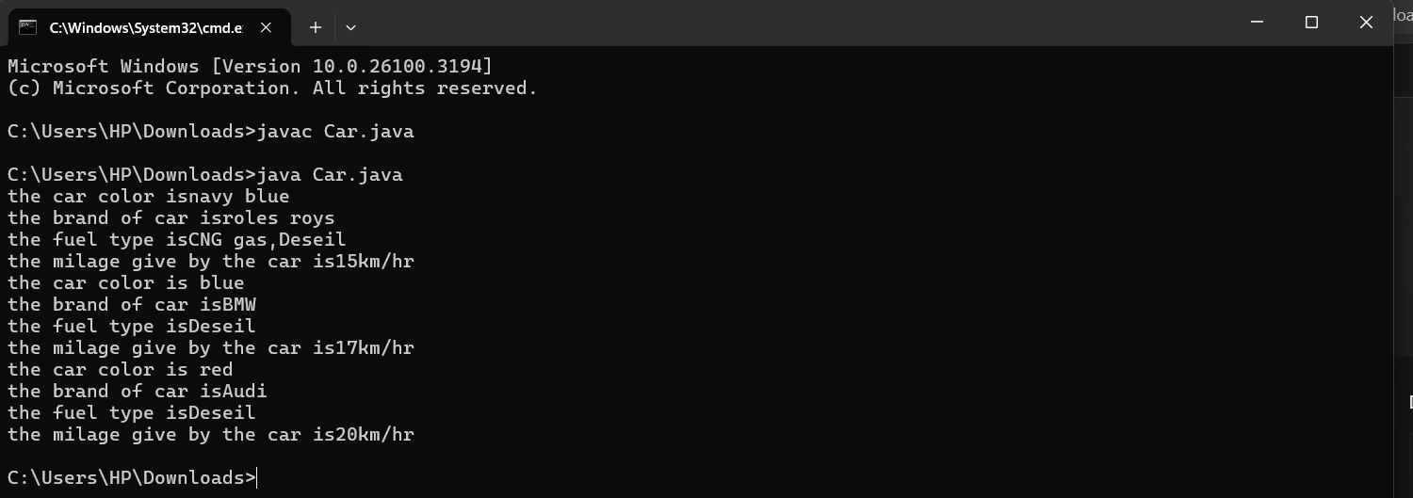

**Error table:**

|  |  |  |  |
| --- | --- | --- | --- |
| S.no | Error name | Cause of error | Rectification |
| 1 | Syntax Error | Missing ‘{‘ | ‘{‘ added |
| 2 | Compile time Error | Mispelled Variable call | Rectified with  Correct variable name |
| 3 | Case sensitive error | Uppercase and lowercase | rectified |

Class diagram:

|  |
| --- |
| **car**  **----------------------**-  -car_color:string  -car_brand:string  -fuel_type:string  -milage:double  ----------------------  +start():void  +stop():void  +service():void |

**2.:**

**Create a class named BankAccount with methods deposit and withdraw, where:**

**The deposit method should accept a parameter amt. When this method is called, the deposit amount should be added to the current balance.**

**The withdraw method should accept a parameter amt. In addition to that, when it is called, it has to verify whether the amount is less than the current balance. If yes, then the current balance is deducted. If not, display a message saying that there is a risk of insufficient funds.**

**Use the constructor to display the details of the customer: (customer name, account number, IFSC, branch).**

**Code:**

**public class BankAccount {**

**protected String accountHolder;**

**protected double balance;**

**protected int accountNumber;**

**public BankAccount(String accountHolder, int accountNumber, double balance) {**

**this.accountHolder = accountHolder;**

**this.accountNumber = accountNumber;**

**this.balance = balance;**

**}**

**public void withdrawal(double amount) {**

**if (amount <= balance) {**

**balance = balance - amount;**

**System.out.println("Current balance: " + balance);**

**} else {**

**System.out.println("Insufficient funds");**

**}**

**}**

**public void deposit(double amount) {**

**balance = balance + amount;**

**System.out.println("Current balance: " + balance);**

**}**

**public static void main(String[] args) {**

**BankAccount BA = new BankAccount("Abdul", 24248, 1000);**

**BA.withdrawal(500);**

**BA.deposit(1500);**

**}**

**}**

**Output:**

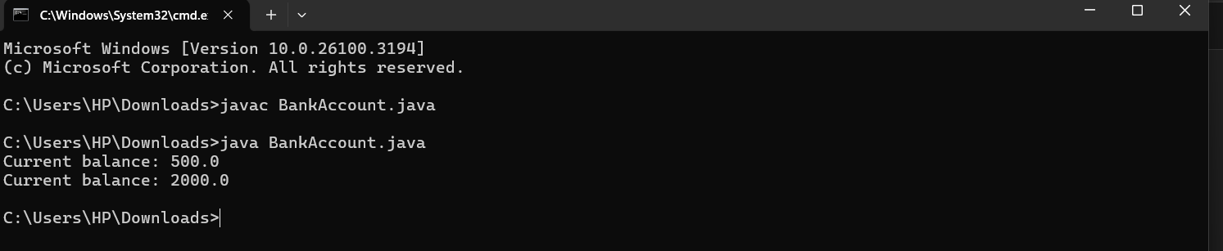

**Error table:**

|  |  |  |  |
| --- | --- | --- | --- |
| **S.no** | **Error name** | **Error name** | **Rectification** |
| **1** | **Name Error** | **Undefined name** | **Correct variable**  **Name replaced** |
| **2** | **Syntax Error** | **Missing Parenthesis** | **Parenthesis Added** |

**CLass Diagram:**

|  |
| --- |
| **BankAccount**  **----------------------------------------------------------**  **-balance: double**  **----------------------------------------------------------**  **+BankAccount(intialBalance: double)**  **+deposit(amount: double):void**  **+withdraw(amount: double):void** |